**Task 3 - Alteryx Workflows**

**Part 1:**

Task_3_Data_Preparation.yxmd

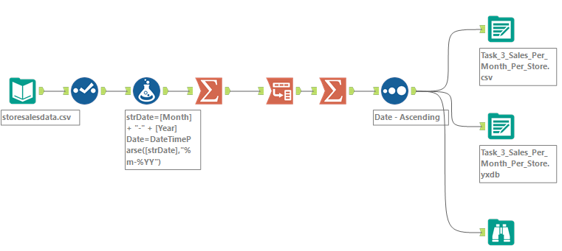

**Part 2:**

Task_3_Forecast_Modelling.yxmd

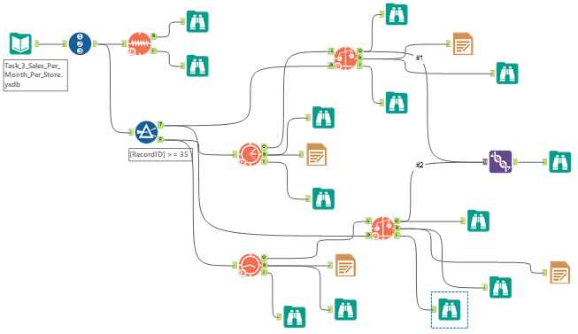

**Part 3:**

Task_3_Final_Forecast_Model.yxmd

